**Adaptability of grapevines to climate change: characterization of phenology and sugar accumulation of a large range of grape varieties, under hot climate conditions.**

Joana Valente, Charles Symington, Pedro Leal da Costa, Frank Steve Rogerson, Ricardo Silva and Fernando Alves.

Symington Family Estates, Vinhos, S.A., Portugal

Presenting author: joana.valente@symington.com

**Keywords:** Adaptation, Climate Change, Douro Region, Phenology, *Vitis vinífera* L.

**Abstract:**

Climate is the major factor influencing the dynamics of the vegetative cycle and can determine the timing of phenological periods. Knowledge about varieties’ phenology, their chronological duration, and thermal requirements, allows not only the better management of interventions in the vineyard, but also to predict varieties’ behaviour under a scenario of climate change, giving the wine producer the possibility of selecting the varieties that are best adapted to the climatic conditions of a certain terroir.

In 2014, Symington Family Estates established two grape variety libraries in two different places with distinctive climate conditions, with the commitment of contributing to a deeper agronomic and oenological understanding of some grape varieties, in hot climate conditions.

Since 2017, phenological observations have been made to determine the average dates of budbreak, flowering and veraison, the thermal requirements and the chronological duration of each phase have been also calculated. During maturation, berry samples have been collected to study the dynamics of sugar accumulation. The data was analysed applying phenological and sugar accumulation models available in literature.

The results obtained show significant differences between the varieties over several parameters, between the two locations, confirming the influence of climate on phenology and maturation, in these specific conditions.

**Introduction:**

Climate conditions play a relevant role in vines’ growth (Jones *et al*., 2005; Lopes *et al*., 2008; Alves *et al*., 2013) and temperature is one of the major factors influencing grapevines’ development (Parker *et al.*, 2011, Malheiro *et al*., 2013; Parker *et al.*, 2013). The expected rise in temperatures caused by climate change can lead to phenology advance and jeopardize the viability of high-quality grape production, in some wine regions (Jones *et al*., 2005; Fraga *et al*., 2012). To counteract this trend and adapt varieties to future climatic conditions, it is important to know grapevines’ thermal requirements to complete the main phenological stages and reach a desired target level of sugar concentration (Parker *et al*., 2020a).

The aim of this research work is to study the influence of climate in a wide range of varieties. The mid-date occurrence for budbreak, flowering (both not shown in this work) and veraison was determined for the cultivars present in two Grape Variety Libraries. To evaluate the dynamic of sugar accumulation, the day of the year (DOY) when a target value of sugar was reached was determined.

**Materials and methods:**

This study was conducted at Symington’s Grape Variety Libraries, located at Quinta do Bomfim (41.189245, -7.540943, Cima Corgo sub-region) and Quinta do Ataíde (41.248395, -7.111794, Douro Superior sub-region), Douro region, Portugal. The vineyards were planted in 2014 with the aim of: studying oenological and viticultural potential; preserving less known cultivars and studying the varieties’ adaptability to climatic conditions. At Ataíde more than 50 varieties are planted, with 200 plants per grape variety, grafted onto 196-17 rootstock. The vines are pruned in Royat single cordon, vertical shoot positioned trellis, with ca 8 to 10 buds per vine. The second grape variety library is smaller than the one above, with 29 grape varieties, grafted onto 196-17 rootstock. The number of plants per cultivar varies from 25 to 75 plants and the vines are pruned in Royat single cordon, vertical shoot positioned and have around 8-10 buds per plant.

The climate in both locations is summarized on table 1. Data from the five years study reveal the most important differences in the two environments. At Quinta do Ataíde we get less annual and growing season precipitation, with lower temperatures during winter and spring, and warmer summers than Quinta do Bomfim, all of which influence the ripening dynamic. The heat accumulation (Growing Degree Days) is quite similar in both places, but with different rates of accumulation, lower at the beginning of the cycle, and faster in late season — from veraison to harvest time — at Quinta do Ataíde.

**Table 1 Climate conditions at Quinta do Bomfim and Quinta do Ataíde from 2017 to 2021. Viticultural year from November to October. Growing season from April to October.**



The phenological records have been registered since 2017, following a strict protocol of observation, the same used in the *VitAdapt Project* (Destrac-Irvine & van Leeuwen, 2016). The observations are performed invariably three times per week at budbreak (stage C), flowering (stage I) and veraison (stage M), according to the Baggiolini scale, always in the same group of plants, with 2 to 4 repetitions per variety, depending on the place.

During ripening, samples of 50 berries/block were collected weekly. The berry quality was analysed for several parameters with FTIR Oenofoss. To define a common target on sugar accumulation, we estimate by two-point linear interpolation the day of the year when each variety reaches a certain level of sugar concentration, following the protocols described in literature (Parker *et al*., 2020). In this study, only the results for Ataíde are presented and although we simulate the accumulation from 170 g/l to 230g/l, only the results for 200g/l of sugar concentration are shown.

**Results and discussion:**

Figure 1 shows the mid-veraison average dates (day of the year) of 29 varieties common to both grape variety libraries for different climatic conditions. The varieties show great variability among them, and we observe that budbreak, flowering and veraison all occur at Bomfim before Ataíde. However, during the period from veraison to maturation, the development is faster at Ataíde, as a consequence of higher temperatures during the summer months.

The range of the interval between the first and the last variety reaching 50% of budbreak at Bomfim is 12 days; 7 days to reach mid-flowering, and 19 days to attain mid-veraison. At Ataíde the range of values is similar: 13 days between the first and the last variety for mid-budbreak, 7 days mid-flowering and 18 days to mid-veraison. The variation of days for reaching 50% of veraison, for 29 varieties in the two places, shows a similar range and a similar categorization for earlier, medium or late varieties, which indicates the genetic behaviour is identical in these varieties under different climatic conditions.

We have also studied the maturation phase, to understand the climatic influence not only in the vines’ phenology but also in grape quality. In this paper we only present the results for Ataíde, for 50 varieties.

  
**Figure 1 Distribution of varieties according to mid-v*e*raison date in Bomfim and Ataíde. Average of 5 years.**

Figure 2 shows the mid-date veraison for 50 varieties, at Ataíde Grape Library and the day of the year (DOY) when each variety reached a target value of 200g/l of sugar. The readings ​​shown were obtained from an interpolation, considering the results of analysis done every week. 2020 was a very hot year, with 47 days recording maximum temperatures above 35ºC, and given that high temperatures influenced the sugar accumulation (Parker *et al.,* 2020b; Suter *et al*., 2021), disturbed the rhythm of sugar accumulation and caused irregular maturation in some varieties, the year was not included in the results.

At Ataíde, the interval of days from the earliest variety to reach 50% of veraison to the last is 19 days. When the interpolation is performed to determine the date when a certain variety reaches 200g/l of sugar accumulation, we see that the order between them changes, which indicates different maturation dynamics and the interval between the first and the last variety to reach the desired level is higher, 35 days over the 5-year average. This reveals a great variability between the cultivars and offers a wide potential of adaptation.

This collection of data will be useful to further studies on modelling the dynamic of the phenology in future climatic scenarios, allowing the winegrower to select the most suitable varieties to face a scenario of climate change, prioritizing late-ripening varieties in places where temperature rises are expected (Santos *et al*., 2021).

**Conclusion:**

The present study represents a valuable tool to understand the climate influence in grape vine varieties phenology and maturation. Knowledge about those characteristics could be very useful to select the most suitable variety for a specific *terroir*. We intend to keep this project a few more years to obtain additional data and thereby build a strong and reliable phenology database, useful for future studies, to apply models and simulate the vines’ response to climate change. Once our grape variety libraries have some cultivars in common with other experimental vineyards, where this kind of work is done, the data could be used to compare the interaction of genotype x environment, with the integration of different terroirs. To broaden the validity of this study, we have applied the same protocol (since 2020) in another experimental vineyard, exclusively dedicated to white varieties (common to the other two libraries), located at considerable altitude elsewhere in the Douro region.

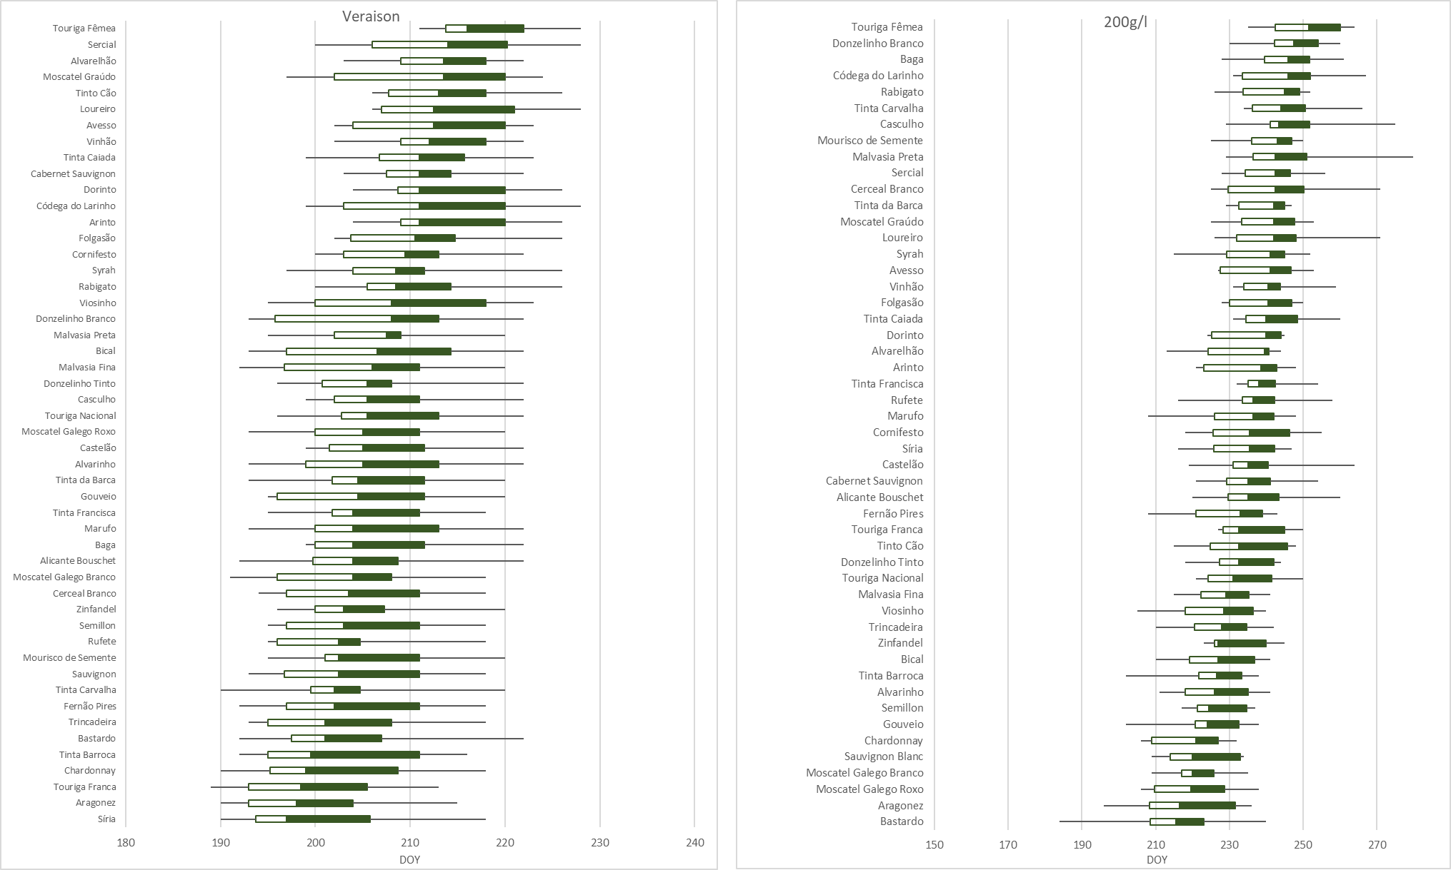

**Figure 2 Classification of varieties by date of mid-veraison and sugar accumulation (target value 200g/l) for 50 varieties (Quinta do Ataíde, Douro Superior).**

**References:**

Alves, F., Edlmann, M., Costa, J., Costa, P., Macedo, P., Leal Da Costa, P., & Symington, C. (2013). Heat requirements and length of phenological stages. Effects of rootstock on red grape varieties at Douro region. 18th International Symposium GIESCO, Porto, Portugal, 7-11, July 2013., 5p.

Destrac Irvine, A., and van Leeuwen, C. (2016). “The VitAdapt project: extensive phenotyping of a wide range of varieties in order to optimize the use of genetic diversity within the Vitis vinifera species as a tool for adaptation to a changing environment,” in Proceedings of the Sustainable Grape and Wine Production in the Context of Climate Change, Bordeaux, 165–171.

Fraga, H., Malheiro, A.C., Moutinho-Pereira, J., Santos, J.A. (2012). An overview of climate change impacts on European viticulture. Food Energy Secur. 1(2):94–110. <https://doi.org/10.1002/fes3.14>

Jones, V.G., White, M.A., Cooper, O.R. and Storchmann, K. (2005). Climate change and global wine quality. Climatic Change, 73: 319–343. <https://doi.org/10.1007/s10584-005-4704-2>

Lopes, J; Eiras-Dias, J.E; Abreu, F; Clímaco, P; Cunha, J.P; Silvestre, J. (2008). Exigências térmicas, duração e precocidade de estados fenológicos de castas da Colecção Ampelográfica Nacional. Ciência Téc. Vitiv. 23 (1) 61-71.

Malheiro, A.C., Campos, R., Fraga, H., Eiras-Dias, J., Silvestre, J., Santos, J.A. (2013). Winegrape phenology and temperature relationships in the Lisbon Wine Region. Portugal. J. Int. Sci. Vigne Vin 47(4): 287–299. <https://doi.org/10.20870/oeno-one.2013.47.4.1558>

Parker, A.; Garcia de Cortazar, I.; van Leeuwen, C.; Chuine, I. (2011). General phenological model to characterise the timing of flowering and veraison of Vitis vinifera L. Aust. J. Grape Wine Res., 17, 206–216. <https://doi.org/10.1111/j.1755-0238.2011.00140.x>

Parker, A., García de Cortázar-Atauri, I., Chuine, I., Barbeau, G., Bois, B., Boursiquot, J.-M., Cahurel, J.-Y., Claverie, M., Dufourcq, T., Gény, L., Guimberteau, G., Hofmann, R.W., Jacquet, O., Lacombe, T., Monamy, C., Ojeda, H., Panigai, L., Payan, J.-C., Lovelle, B.R., Rouchaud, E., Schneider, C., Spring, J.-L., Storchi, P., Tomasi, D., Trambouze, W., Trought, M. and van Leeuwen, C. (2013). Classification of varieties for their timing of flowering and veraison using a modelling approach: a case study for the grapevine species Vitis vinifera L. Agric For Meteorol, 180: 249-264. <https://doi.org/10.1016/j.agrformet.2013.06.005>

Parker, A.K., García de Cortázar-Atauri, I., Trought, M. C. T., Destrac, A., Agnew, R., Sturman, A. and van Leeuwen, C. (2020a). Adaptation to climate change by determining grapevine cultivar differences using temperature-based phenology models. OENO One 2020, 4, 955-974. <https://doi.org/10.20870/oeno-one.2020.54.4.3861>

Parker, A.K., García de Cortázar-Atauri, I., Gény, L., Spring, J., Destrac, A., Schultz, H., Molitor, D., Lacombe, T., Graça, A., Monamy, C., Stoll, M., Storchi, P., Trought, M.C.T., Hofmann, R.W., van Leeuwen, C. (2020b). Temperture-based grapevine sugar ripeness modelling for a wide range of Vitis vinifera L. cultivars. Agricultural and Forest Meteorology, 285-286, 107902. <https://doi.org/10.1016/j.agrformet.2020.107902>

Santos, J., Young, C., Fraga, H.; Malheiro, A., Moutinho-Pereira, J., Dinis, L-T, Correia, C., Moriondo, M., Bindi, M., Leolini, L., Dibari, C., Costafreda-Aumedes, S., Bartolini, N., Kartschall, T., Menz, C., Molitor, D., Junk, J., Beyer, M. and Schultz, H. (2021). Long-term adaptation of European viticulture to climate change: an overview from the H2020 Clim4Vitis action. IVES Technical Reviews vine and wine. <https://doi.org/10.20870/IVES-TR.2021.4644>

Suter, B., Destrac Irvine, A., Gowdy, M., Dai, Z. & van Leeuwen, C. (2021). Adapting Wine Grape Ripening to Global Change Requires a Multi-Trait Approach. Front. Plant Sci., 12:624867. <https://doi.org/10.3389/fpls.2021.624867>